European Conference on Antennas and Propagation 2011, 11-15 April 2011, Rome

REPLACE THIS SENTENCE WITH THE TITLE OF YOUR ABSTRACT.
A. B. Author¹ and C. D. Author², ¹Affiliation (include full mailing address and e-mail address if desired) for first author, ²Affiliation for second author (full mailing address and e-mail address).

Introduction: Replace these instructions with the text of your abstract. Do NOT delete the heading or the section break above. The columns are set to a width of 8 cm. (Please make sure your paper size is set to A4 (21 cm x 29.7 cm), before submitting your abstract.) Page margins are set to be 2.3 cm on the left and right sides and 2 cm at the top and bottom.
The abstract size is restricted to TWO pages including figures and references. Longer abstracts will not be accepted.
Please submit a .PDF-VERSION of your abstract.
Heading Styles: The section heads in this template use the correct style (upper and lower case, bold, followed by a colon). The format for second-level heads is show below:
Sample of a level-two head. Automatic paragraph indents are imbedded to appear every time you use a hard return. If you’re using the spell checker and it doesn’t seem to be working, check the “Language” option under the “Tools” to make sure that “No Proofing” isn’t selected as the default. You should also check that the default font is Times New Roman and not New York (this conversion takes place on some Macintosh systems).
References: Use the brief numbered style common in many abstracts, e.g., [1], [2], etc. References should then appear in numerical order in the reference list, and should use the standard IEEE style at the end of the abstract text.
Figures and tables: Figures and tables must be clear and readable after the pdf conversion. For easier editing they can be appended at the end of the text.
Additional Information: Any changes to your abstract after submission can be done through your personal log in page, till Jan 31th. The link and log in details to this page will be provided in a confirmation email. In case of a withdrawal or problems with the abstract guidelines/abstract preparation please contact the EuCAP 2010 secretariat at:
EuCAP2011@realize-events.de
References
- S. M. Lettuce and V. P. Cabbage, Hydroponic is the way, 2nd ed., R. M. Ackermann Jr., Ed. Berlin, Germany: Springer-Verlag, 1998.
- S. Smith, C. Jones, “A novel ultraefficient easy-to-buid cheap antenna,” IEEE Trans on Antennas and Propagation ., vol. 120, pp. 569–571, Nov. 1999.
- J.Daniel, J. Glen, P. Jameson, , “Maxwell and other great Scottish contributions to world advancement”, European Conference on Antennas and Propagation EUCAP 2007, Edinburgh , 11-16 November 2007, pp. 109-111.

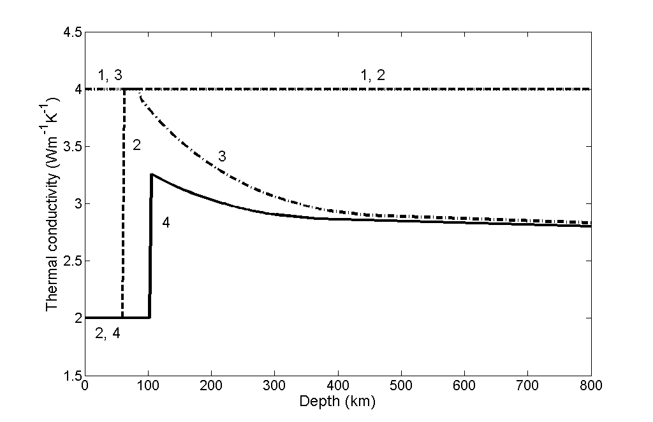

Fig.1: Example for a figure and figure caption

